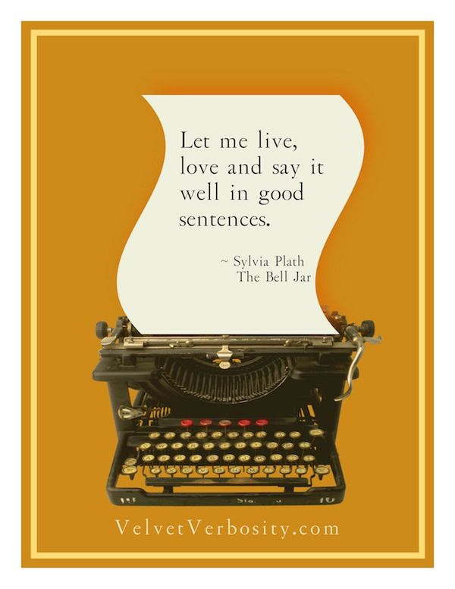
KS3 Writing Skills Booklet
Name…………………………………
Class………………………………....

Narrative Writing - Session 1

Starter Task: Correct the sentences so they are all correctly in the past tense:
Example: My first day at school is amazing - My first day at school was amazing.

- I hopped out of the car, dash up the stairs and ran into school, just in time.
……………………………………………………………………………………………………………………………………………………………………………………………...
- Smiling proudly, my mum waved and says, “Have you had a good day?”
……………………………………………………………………………………………………………………………………………………………………………………………...
- I walk into the canteen and the salty aroma of chips welcomed me.
……………………………………………………………………………………………………………………………………………………………………………………………...
- Mrs Paton ran in, smiles, hands out our timetables and then dashed out again.
……………………………………………………………………………………………………………………………………………………………………………………………...
- Frowning, Miss Dann stopped Luke, tells him to fix his tie and then orders him to get to class.
……………………………………………………………………………………………………………………………………………………………………………………………...
- Aisha, who had dashed into the class after the bell, is told off by Miss Dann.
……………………………………………………………………………………………………………………………………………………………………………………………...
- The students was late to their class as they will get lost.
………………………………………………………………………………………………………………………………………………………………………………………………

Write your own incorrect sentences to challenge other students.

Writing Challenge 1 - Write a story titled ‘The First Day’. Your story must be in the first person and the past tense.

Type?

Audience?

Purpose?

New Vocabulary
Narrative - a piece of writing with a story.
Narrator - the person who tells (narrates) a story.
Narrative voice - the perspective a story is told from.
Figurative language - using figures of speech to create an image for the reader.

Opening Lines
Discuss: Which one do you think is the best and why?
It was a bright, cold day in April and the clocks were striking 13. 1984, George Orwell

All children, except one, grow up. Peter Pan, JM Barrie

The great gray beast February had eaten Harvey Swick alive. The Thief of Always, Clive Barker

Lyra and her dæmon moved through the darkening Hall, taking care to keep to one side, out of sight of the kitchen. Northern Lights, Philip Pullman

There was a hand in the darkness, and it held a knife. The Graveyard Book, Neil Gaiman

What is the opening line of your reading book? Do you think it is good or bad? Why?

Successful Narrative Ingredients

Read the stories on the next pages (from the BBC 500 Word Competition) and bullet point the ingredients for brilliant narrative writing.
- ……………………………………………………………………………………………...
- ……………………………………………………………………………………………...
- ……………………………………………………………………………………………...
- ………………………………………………………………………………………………
- ……………………………………………………………………………………………...
- ……………………………………………………………………………………………...
- ……………………………………………………………………………………………...
- ………………………………………………………………………………………………
- ……………………………………………………………………………………………...
- ……………………………………………………………………………………………...
- ……………………………………………………………………………………………...
- ………………………………………………………………………………………………
- ……………………………………………………………………………………………...
- ……………………………………………………………………………………………...

I should’ve stayed at home… By Henry Doust
It was one of those contrary days, the sky was blue, it looked warm from indoors but there was still a February bite in the air. I was wearing my usual camo pants, long sleeve tee and boots, I'd heard the shout to put a coat on, but I'd ignored it, I just wanted to get outside.
There were six of us at the beginning, happy, laughing, just being kids really, I don't know where they are now or what happened to them.
We aren't really even friends anymore, just a bunch of kids I used to know from primary school, grouped together by geography. We didn't go to the same schools anymore though and we'd drifted apart, found new friends as our worlds had changed and grown. So, it was strange how we all ended up together today.
I'm not sure how it started either, but I was involved, and I had to be quiet now. As silent as the grave and just as still. Make myself small. Tucked in. I could listen for sounds. Check for movement, but not make any. I must not be found. When it was very quiet, I could risk looking out, very carefully, lifting my head up and slightly to the side, with my breath held and my heart pounding like a hammer on a blacksmith's anvil.
I had only been brave enough to look once. And then, I thought I'd been seen. My heart had stopped, sweat had coated my body like a second skin but nothing more had happened. I was getting cold like an abandoned meal. I'm not sure how long I've been still for, trying to make myself as tiny as the insects around me. My arms and legs are getting numb, pulled together, tired of being held in the same position. But I daren't move. I know it will lead to pins and needles, and then cramps. But I don't mind the numbness, it is comforting and the longer I endure it, the longer I can stay still and safe.
It's been an age now, an ice age and I'm just as cold. I can't hear anything, but everything hurts. I am calmer now, my heart beat has finally slowed, the adrenalin is dispersing, and I can think: am I safe here? Should I risk moving further away? I want to have look.
Then, suddenly: out of the silence, running, thumping footsteps. Then, slow, cautious steps, and voices. Muffled, twisted voices, speaking quickly, I couldn't make out what they were saying, but they were getting nearer. I made myself even smaller, contracting my screaming limbs. I held my breath. The footsteps came nearer, the voices stopped. I willed my heartbeats to quieten.
Then I felt the shadow fall over me. Heavy with despair, I closed my eyes and exhaled. A large sweaty hand grabbed me with a steel grip accompanied by a booming voice bellowing 'GOT YOU!'
'Damn it'! I cursed, now it was my turn to count.

Dancing on the Streets by Sadhbh Inman

Tai ya tai hi
Tai ya tai hi...
On a noisy, dusty road, a child's bare brown feet are hardly noticed as she weaves in and out of the traffic, dodging cattle and halting at taxis. She presses her nose against the windows of vehicles carrying crowds of tourists. "Tissues ma'am, tissues sir, only ten rupees for a box". Sita is small for a seven year old, but then seven year olds from the slums in Ahmedabad are often smaller than other children.
Tai ya tai hi
Tai ya tai hi...
The Bharata Natyam rhythm encourages her to dance, from car to lorry, lorry to rickshaw. On Sita's tiny face a smile begins to form. She is so engrossed in the rhythm that she never misses a beat. A lady in a rickshaw spots her quick-footed movements and starts rummaging through her purse to find twenty rupees, "ten rupees for the tissues and ten for your dancing".
Tai ya tai hi
Tai ya tai hi…
Sita is delighted about receiving that much money, and dances off to the tailor's to get her Bharata Natyam dress made and her dream fulfilled. The tailor's fingers work quickly with the silky, emerald fabric. The gleaming needle punctures the soft cotton cloth, creating neat rows of stitches. Sita watches as the dress is completed. Sita takes the dress, her eyes wide with excitement, her mouth open in anticipation. "That's one hundred rupees child" the tailor says kindly. Sita carefully unfolds the notes she has been saving for over a year and with a hopeful sigh, hands them over.
"I'll have that!" a voice booms. Sita stands, her back to the stranger. She strongly smells rum. "Oh! It can't be" she murmurs. A dark shadow and fiery breath indicate his presence..."Uncle!" His eyes narrow menacingly, sending a shiver down Sita's spine. "I'll have that!" he booms again. Uncle takes the money off Sita. He turns around and slams the door behind him.
Sita knows it will be the end of her happiness. It feels like a part of her body is gone, fatally gone forever. Sita also knows that she should have given the money to Uncle, but it didn't seem fair that he sent her to get money, to make him a rich man.
Tai ya tai hi
Tai ya tai hi...
On a noisy, dusty road, a child's bare brown feet are hardly noticed as she weaves in and out of the traffic, dodging cattle and halting at taxis.
"Tissues ma'am, tissues sir ...only ten rupees for a box".

Narrative Writing - Session 2
Starter Task: How do you write the perfect sentence? Turn these fragments into full sentences.
Example: the pupil - The pupil learnt about sentences.
- entered the classroom
……………………………………………………………………………………………………………………………………………………………………………………………...
- the teacher
……………………………………………………………………………………………………………………………………………………………………………………………...
- put up their hands
……………………………………………………………………………………………………………………………………………………………………………………………...
- received their Sharples’ ties
……………………………………………………………………………………………………………………………………………………………………………………………...
- the form teacher
………………………………………………………………………………………………………………………………………………………………………………………………
Turn your sentences into complex sentences, e.g. The pupil, who was in an English lesson, learnt about sentences.

Sentence Practice: Verb, person sentence
Example: Holding my breath, I walked through the school gates.

- Looking up at the older pupils,…………………………………………………………..
……………………………………………………………………………………………..
- Scanning the playground for my friends,……………………………………………….
……………………………………………………………………………………………...
- Breathing a sigh of relief,.....................................................................................
……………………………………………………………………………………………...
- Hurrying…………………………………………………………………………………………………………………………………………………………………………………...
- Smiling……………………………………………………………………………………..………………………………………………………………………………………………

Writing Workshop: Think back to your first day at Sharples. Write three verb, person sentences that describe your experience.

……………………………………………………………………………………………………………………………………………………………………………………………………………...
……………………………………………………………………………………………………………………………………………………………………………………………………………...
……………………………………………………………………………………………………………………………………………………………………………………………………………...
……………………………………………………………………………………………………………………………………………………………………………………………………………...
……………………………………………………………………………………………………………………………………………………………………………………………………………...
……………………………………………………………………………………………………………………………………………………………………………………………………………...
……………………………………………………………………………………………………………………………………………………………………………………………………………...
……………………………………………………………………………………………………………………………………………………………………………………………………………...
……………………………………………………………………………………………………………………………………………………………………………………………………………...
……………………………………………………………………………………………………………………………………………………………………………………………………………...
Self-Assessment Check
- Is my sentence punctuated correctly?
- Does it capture my feelings?
- Is it in the past tense?
- Could I improve the vocabulary?
- Could I add descriptive adjectives or adverbs?

- Could I add an extra subordinate clause?
- Could I add figurative language?


Ready, Steady, Read
Pakistani schoolgirl Malala Yousafzai, who was shot in the head by the Taliban after campaigning for girls' rights to education, has attended her first day at school in the UK.

The 15-year-old was shot on a school bus in Pakistan in October.

She has now recovered following treatment at Birmingham's Queen Elizabeth Hospital.
She described starting at the city's Edgbaston High School for Girls as "the most important day" of her life.

She said: "I think it is the happiest moment that I'm going back to school, this is what I dreamed, that all children should be able to go to school because it is their basic right.

"I am so proud to wear the uniform because it proves I am a student and that I am living my life and learning."

Malala is in year nine and will start her GCSE curriculum next year.

She said she was looking forward to learning about politics and law.

Questions:
- What is the type, audience and purpose?
………………………………………………………………………………………………

- Why was Malala shot?
………………………………………………………………………………………………

- Where was Malala treated for her injuries?
………………………………………………………………………………………………

- What year is she starting in?
………………………………………………………………………………………………

- What is she looking forward to learning about?
………………………………………………………………………………………………

- What type of clause is underlined?
………………………………………………………………………………………………

- The writer uses a quote from Malala. Why does the writer use a quote?
………………………………………………………………………………………………

Narrative Writing - Session 3

Starter Task: Organise the Verb, person sentences so they make sense.
Carefully add in commas and full stops.

- Breathing sigh relief spot my a of best I friend

- up the intimidated Looking at older feel pupils I
………………………………………………………………………………………………
………………………………………………………………………………………………

- down Hurrying corridor barge past pupils the me
………………………………………………………………………………………………
………………………………………………………………………………………………

- playground see friends don’t of recognise I faces for my the I swarms Scanning

- happily to wave I friends smiling goodbye new my
………………………………………………………………………………………………
………………………………………………………………………………………………

Change the order of the information in the sentences.
Example: I spot my best friend, then breathe a sigh of relief.
Spotting my best friend, I breathe a sigh of relief.

Sentence Practice: Emotion word, comma sentence
Example: Concerned, the teacher bent down to smile at me.
Happily, I waved at my friend.
- Terrified, I crept across the creaking floorboards of the haunted house.
- Relieved, I………………………………………………………………………………...
- Anxiously, he...…………………………………………………………………………..
- Overjoyed………………………………………………………………………………...
- Petrified...…………………………………………………………………………………

Writing Workshop:

Activity 1: Use a thesaurus to find at least three synonyms for each word.
Highlight your three favourite words.

- Happy -
- Nervous -
- Scared -
- Proud -
- Excited -
Activity 2: Think back to your first day at Sharples. Write three Emotion word, comma sentences that describe your experience. These sentences need to be perfect before they go into the Sentence Store.
……………………………………………………………………………………………………………………………………………………………………………………………………………...
……………………………………………………………………………………………………………………………………………………………………………………………………………...
……………………………………………………………………………………………………………………………………………………………………………………………………………...
……………………………………………………………………………………………………………………………………………………………………………………………………………...
……………………………………………………………………………………………………………………………………………………………………………………………………………...
………………………………………………………………………………………………………
Self-Assessment Check
- Is my sentence punctuated correctly?
- Does it capture my feelings?
- Is it in the past tense?
- Could I improve the vocabulary?
- Could I add descriptive adjectives or adverbs?
- Could I add an extra subordinate clause?
- Could I add figurative language?
Ready, Steady, Read
First day of school: 10 tips on helping your child as they start primary school

Is your little one starting school? Read these tips on helping them to settle in.
Starting school is a big step for any child, but there are ways to help them feel more comfortable as they begin this new phase in their lives.
With September looming, we've put together a list of tips on how to help your child in those nerve-racking days before school begins, on the first day and as they settle in to their new routine.

Get organised: Make sure you've got everything they need in time for your child's first day. Include them in decision making processes - even if it's just choosing a lunchbox - to get them excited about starting school. Label their clothes and show them where the label is, so they can check it themselves.

Talk about what they can expect: Explain to your child about school rules, routines and schedules so they know what to expect. Assure them that the teacher is there to help, and that you will be there at the end of every day to talk to them. You could even tell them a bit about your own experiences at school.

Questions:
- What is the type, purpose and audience?
………………………………………………………………………………………………

- What two specific tips does the writer give for getting organised?
………………………………………………………………………………………………
………………………………………………………………………………………………

- Who will be there to help at school?
………………………………………………………………………………………………

- The underlined words are commands. Why does the writer use them?
………………………………………………………………………………………………
………………………………………………………………………………………………

- The writer uses direct address (talking directly to the reader, e.g. you). Why does the writer use this device?
………………………………………………………………………………………………
………………………………………………………………………………………………
The word loom means to appear in a threatening way.se the word loom, loomed or looming in a sentence.

Narrative Writing - Session 4
Starter Task: Below are some incorrect emotion word, comma sentences.
Rewrite them so they are correct.

- confused he wrinkled his forehead
………………………………………………………………………………………………

- Angrily shouting at the class
………………………………………………………………………………………………

- Embarrased her fase flushd read
………………………………………………………………………………………………

- Amused rolled her eyes at the boy’s joke
………………………………………………………………………………………………

- Hungrily he
………………………………………………………………………………………………
Organise these three pieces of information into a sentence.
The girl was shocked
She gasped
A boy threw food.
Punctuation Practice: Direct Speech
Example: “Welcome to Sharples,” Ms Webster proclaimed.
Ms Webster proclaimed, “Welcome to Sharples.
- My form tutor asked what is your name
- Are you lost asked a Gold Tie student
- I had a great first day I exclaimed
- I wonder said my friend what our English teacher will be like
- The teacher frowned Do not shout out he yelled
Writing Workshop
Think back to your first day at Sharples. Write a conversation from that day, using direct speech punctuation correctly.
……………………………………………………………………………………………………………………………………………………………………………………………………………...
……………………………………………………………………………………………………………………………………………………………………………………………………………...
……………………………………………………………………………………………………………………………………………………………………………………………………………...
……………………………………………………………………………………………………………………………………………………………………………………………………………...
……………………………………………………………………………………………………………………………………………………………………………………………………………...
……………………………………………………………………………………………………………………………………………………………………………………………………………...
……………………………………………………………………………………………………………………………………………………………………………………………………………...
……………………………………………………………………………………………………………………………………………………………………………………………………………...
……………………………………………………………………………………………………………………………………………………………………………………………………………...
………………………………………………………………………………………………………
Self-Assessment Check
- Are the speech marks correct?
- Is there always punctuation before the speech marks?
- Does the direct speech begin with capital letters?
- Is there a new line for a new speaker?
- Could I improve the vocabulary?
- Could I add descriptive adjectives or adverbs?

- Could I add extra details using subordinate clauses?
- Could I add figurative language?

Ready, Steady, Read

The refectory was a great, low-ceilinged, gloomy room; on two long tables smoked basins of something hot, which, however, to my dismay, sent forth an odour far from inviting. I saw a universal manifestation of discontent when the fumes of the repast met the nostrils of those destined to swallow it; from the van of the procession, the tall girls of the first class, rose the whispered words —
"disgusting! The porridge is burnt again"!

Questions:
- Find two adjectives that describe the refectory (canteen).

………………………………………………………………………………………………
………………………………………………………………………………………………

- How is the odour (smell) coming from the porridge described?

………………………………………………………………………………………………

- Find two synonyms for sadness in the passage.

………………………………………………………………………………………………
………………………………………………………………………………………………

- Why might the response to the smell of the porridge be ‘whispered’ by the students?

………………………………………………………………………………………………
………………………………………………………………………………………………

- Fix the errors in the direct speech.

………………………………………………………………………………………………
The word manifestation means the action of showing something, e.g. The bags under the woman’s eyes were a manifestation of her tiredness.

Use the word manifestation in a sentence.

Narrative Writing - Session 5
Starter Task: In the sentences below, direct speech punctuation is used incorrectly.
Rewrite them so they are correct.

- Furiously, the teacher yelled stop messing around
- Hurrying down the corridor, the boy bellowed “get out of my way”!
- “Did you have a good day,” asked my mum.
- Welcome proclaimed Ms Webster to Sharples School.
- “The boy’s hand” shot up as soon as “Miss Amdavadi” asked the question.
Write your own incorrect sentences to challenge other students.

Sentence Practice: Noun, which, where, who sentence
Example: Miss Molyneux, who was excited to meet the new Year 7 pupils, smiled broadly.
The playground, where Year 7 pupils could go at lunchtime, was the biggest in the school.
The homework, which was due in tomorrow, was to research Shakespeare’s life.
- The boy, who…………………………………………………………………………….

………………………………………………………………………………………………

- The canteen, where……………………………………………………………………..

………………………………………………………………………………………………

- My pencil case, which...……………………………………………………………….

………………………………………………………………………………………………

- Fatima...…………………………………………………………………………………..

………………………………………………………………………………………………

- The school gates...……………………………………………………………………..

………………………………………………………………………………………………

Writing Workshop
Think back to your first day at Sharples. Write three Noun, which, where, who sentences that describe your experience. These sentences need to be perfect before they go into the Sentence Store.
……………………………………………………………………………………………………………………………………………………………………………………………………………...
……………………………………………………………………………………………………………………………………………………………………………………………………………...
……………………………………………………………………………………………………………………………………………………………………………………………………………...
……………………………………………………………………………………………………………………………………………………………………………………………………………...
……………………………………………………………………………………………………………………………………………………………………………………………………………...
……………………………………………………………………………………………………………………………………………………………………………………………………………...
……………………………………………………………………………………………………………………………………………………………………………………………………………...
……………………………………………………………………………………………………………………………………………………………………………………………………………...
……………………………………………………………………………………………………………………………………………………………………………………………………………...
………………………………………………………………………………………………………………………………………………………………………………………………………………
Self-Assessment Check
- Is my sentence punctuated correctly?
- Does it capture my feelings?
- Is it in the past tense?
- Could I improve the vocabulary?
- Could I add descriptive adjectives or adverbs?

- Could I add an extra subordinate clause?
- Could I add figurative language?

Ready, Steady, Read
Harry had never even imagined such a strange and splendid place. It was lit by thousands and thousands of candles which were floating in midair over four long tables, where the rest of the students were sitting. These tables were laid with glittering golden plates and goblets. At the top of the hall was another long table where the teachers were sitting. Professor McGonagall led the first-years up here so that they came to a halt in a line facing the other students, with the teachers behind them. The hundreds of faces staring at them looked like pale lanterns in the flickering candlelight. Dotted here and there around the students, the ghosts shone misty silver. Mainly to avoid all the staring eyes, Harry looked upwards and saw a velvety black ceiling dotted with stars. He heard Hermione whisper, "It's bewitched to look like the sky outside, I read it in Hogwarts: A History."

Questions:
- What is the type, purpose and audience?
………………………………………………………………………………………………
………………………………………………………………………………………………

- How is the Great Hall lit?
………………………………………………………………………………………………

- Who sits on the table at the top of the hall?
………………………………………………………………………………………………

- Why does Harry look upwards?
………………………………………………………………………………………………

- Look at the underline words. What device has the writer used here?
………………………………………………………………………………………………

- What does the final sentence suggest about Hermione’s character?
………………………………………………………………………………………………
………………………………………………………………………………………………

Narrative Writing - Session 6

Sentence Practice: Show Don’t Tell
Example: I was happy at the end of the day.

Smiling, I waved goodbye to my new friends and skipped out of the school, swinging my bag.

- The boy was naughty.
………………………………………………………………………………………………………………………………………………………………………………………………
- I was worried about the first day of school.
………………………………………………………………………………………………
………………………………………………………………………………………………

- I am relieved that my form tutor is nice.
………………………………………………………………………………………………
………………………………………………………………………………………………

- The older students seem scary.
………………………………………………………………………………………………
………………………………………………………………………………………………

- The food in the canteen is tasty.
………………………………………………………………………………………………
………………………………………………………………………………………………

Write Emotion,comma/Verb,person and Noun, which/where/who sentences that show not tell.

Writing Workshop
Think back to your first day at Sharples. Write three examples of Show Don’t Tell sentences. These sentences need to be perfect before they go into the Sentence Store.
……………………………………………………………………………………………………………………………………………………………………………………………………………...
……………………………………………………………………………………………………………………………………………………………………………………………………………...
……………………………………………………………………………………………………………………………………………………………………………………………………………...
……………………………………………………………………………………………………………………………………………………………………………………………………………...
……………………………………………………………………………………………………………………………………………………………………………………………………………...
……………………………………………………………………………………………………………………………………………………………………………………………………………...
……………………………………………………………………………………………………………………………………………………………………………………………………………...
……………………………………………………………………………………………………………………………………………………………………………………………………………...
Self-Assessment Check
- Is my sentence punctuated correctly?
- Does it capture an emotion/a character?
- Is it in the past tense?
- Could I improve the vocabulary?
- Could I add descriptive adjectives or adverbs?
- Could I add an extra subordinate clause?
- Could I add figurative language?

Ready, Steady, Read

The door was hit with such force that it swung clean off its hinges and with a deafening crash landed flat on the floor.

A giant of a man was standing in the doorway. His face was almost completely hidden by a long, shaggy mane of hair and a wild, tangled beard, but you could make out his eyes, glinting like black beetles under all the hair.

The giant squeezed his way into the hut, stooping so that his head just brushed the ceiling. He bent down, picked up the door, and fitted it easily back into its frame. The noise of the storm outside dropped a little.

He turned to look at them all.
"Couldn't make us a cup o' tea, could yeh? It's not been an easy journey..."

He strode over to the sofa where Dudley sat frozen with fear.
"Budge up, yeh great lump," said the stranger.

Questions:
- What is your first impression of Hagrid from this extract?
………………………………………………………………………………………………
………………………………………………………………………………………………
………………………………………………………………………………………………
………………………………………………………………………………………………

- Find the simile. What effect does it have?
………………………………………………………………………………………………
………………………………………………………………………………………………

- Find two details that suggest Hagrid might be a kind man.
………………………………………………………………………………………………
………………………………………………………………………………………………

- The underlined sentence is an example of pathetic fallacy. This is when the setting reflects the mood. What mood is the writer creating here?

………………………………………………………………………………………………
………………………………………………………………………………………………
………………………………………………………………………………………………
………………………………………………………………………………………………
………………………………………………………………………………………………

Narrative Writing - Session 7

Stories often follow a story arc.
Discuss: How do famous stories such as fairy tales follow this arc?
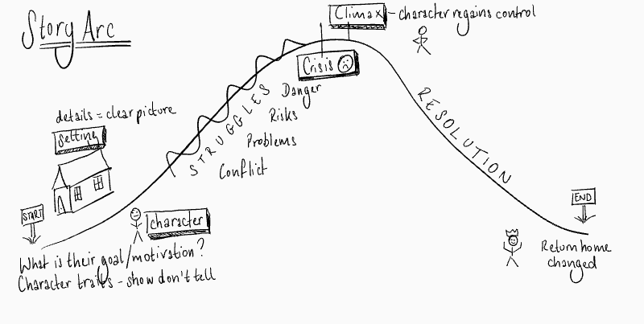

Plot your story on the Story Arc.

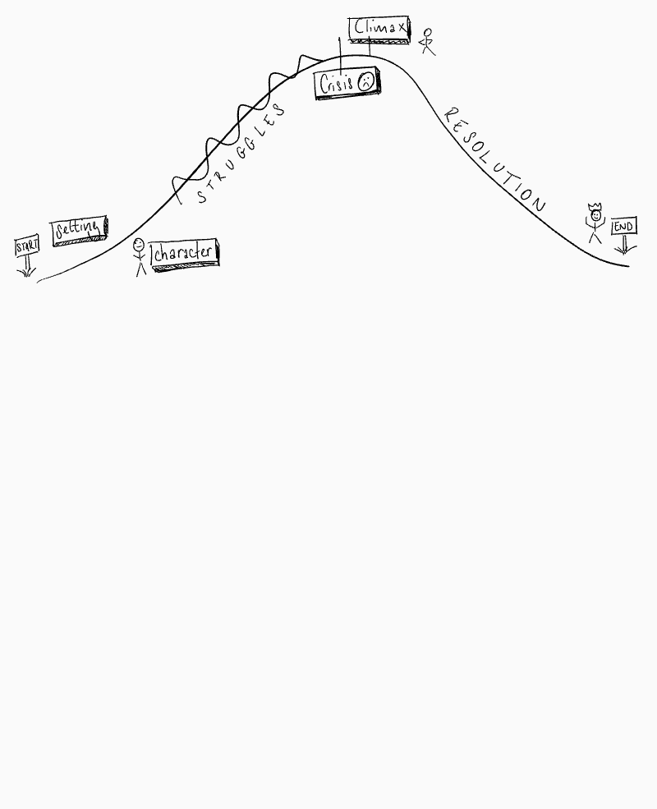

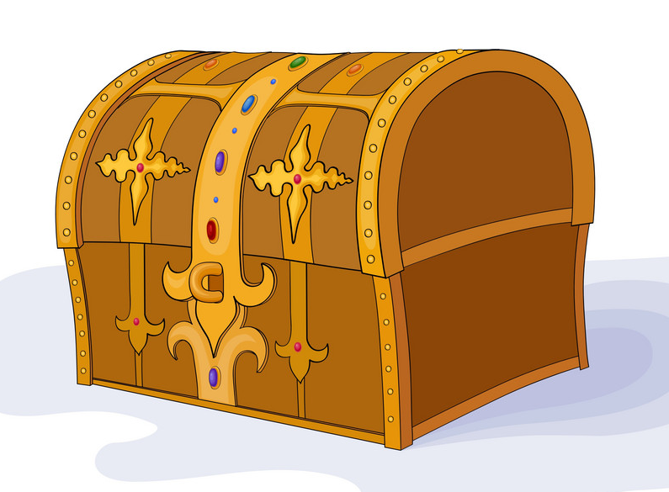
Sentence Store
………………………………………………………………………………….
……………………………………………………………………………………………………………………………………………………………………………………………………………...
……………………………………………………………………………………………………………………………………………………………………………………………………………...
……………………………………………………………………………………………………………………………………………………………………………………………………………...
……………………………………………………………………………………………………………………………………………………………………………………………………………...
……………………………………………………………………………………………………………………………………………………………………………………………………………...
……………………………………………………………………………………………………………………………………………………………………………………………………………...
……………………………………………………………………………………………………………………………………………………………………………………………………………...
……………………………………………………………………………………………………………………………………………………………………………………………………………...
……………………………………………………………………………………………………………………………………………………………………………………………………………...
………………………………………………………………………………………………………………………………………………………………………………………………………………
……………………………………………………………………………………………………………………………………………………………………………………………………………...
……………………………………………………………………………………………………………………………………………………………………………………………………………...
………………………………………………………………………………………………………………………………………………………………………………………………………………
……………………………………………………………………………………………………………………………………………………………………………………………………………...
……………………………………………………………………………………………………………………………………………………………………………………………………………...
……………………………………………………………………………………………………………………………………………………………………………………………………………………………………………………………………………………………………………………………………………………………………………………………………………………………...
……………………………………………………………………………………………………………………………………………………………………………………………………………...
……………………………………………………………………………………………………………………………………………………………………………………………………………………………………………………………………………………………………………………………………………………………………………………………………………………………...
……………………………………………………………………………………………………………………………………………………………………………………………………………...
……………………………………………………………………………………………………………………………………………………………………………………………………………………………………………………………………………………………………………………………………………………………………………………………………………………………...
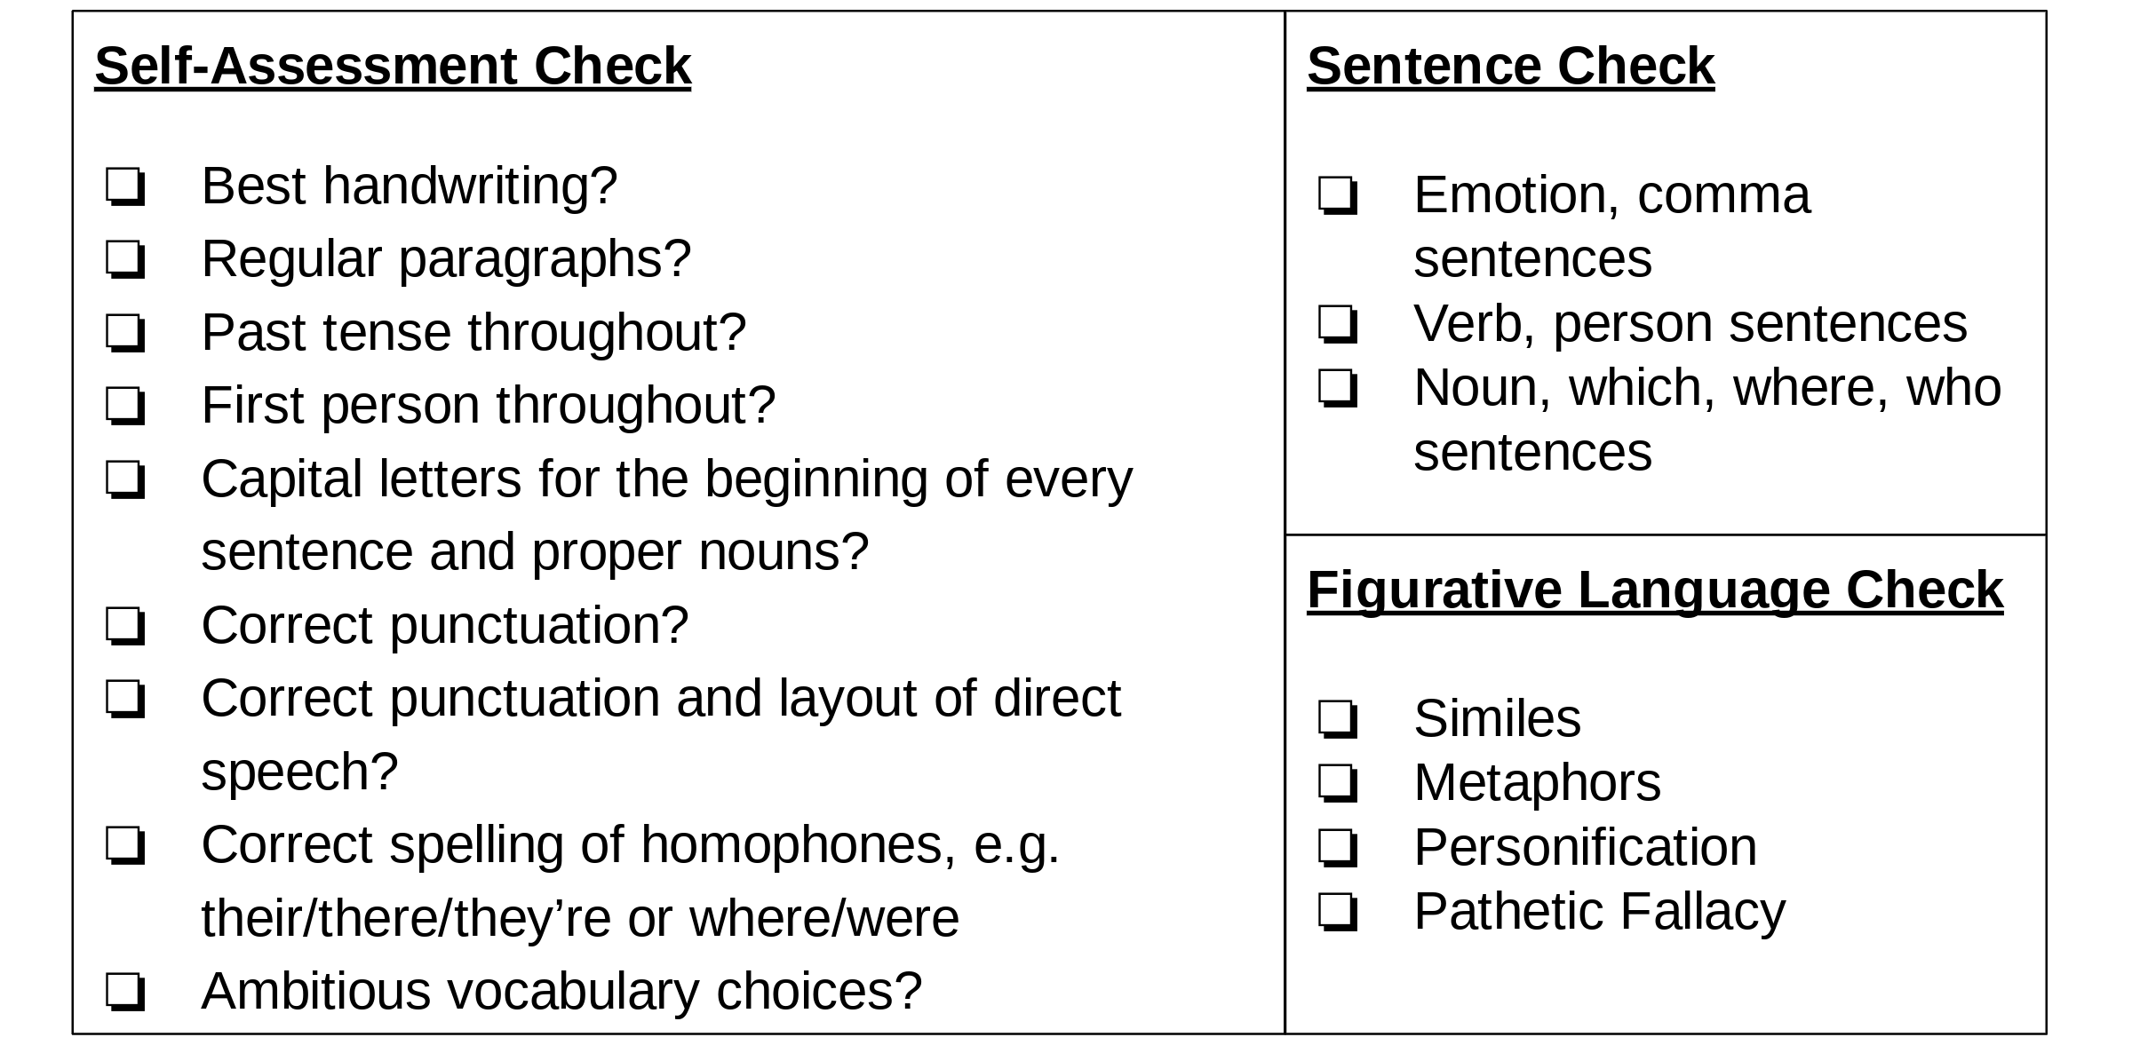
………………………………………………………………………………………………………Writing Challenge 1 - Write a story titled ‘The First Day’. Your story must be in the first person and the past tense.

Rhetorical Writing - Session 1
Starter Task: Complete the story.
Slowly, a foot moved, then the trunk, then a loud growl shook the cavern…
Continue the description, using:

- A Noun, which, where, who sentence
- A emotion word, comma sentence
- A Verb, person sentence
- Show don’t tell
- Direct speech
……………………………………………………………………………………………………………………………………………………………………………………………………………...
……………………………………………………………………………………………………………………………………………………………………………………………………………………………………………………………………………………………………………………………………………………………………………………………………………………………...
……………………………………………………………………………………………………………………………………………………………………………………………………………...
……………………………………………………………………………………………………………………………………………………………………………………………………………………………………………………………………………………………………………………………………………………………………………………………………………………………...
……………………………………………………………………………………………………………………………………………………………………………………………………………...
………………………………………………………………………………………………………………………………………………………………………………………………………………………………………………………………………………………………………………………

Writing Challenge 2 - As well as the Night at the Museum trip, Mrs Molyneux is thinking of organising another Year 7 trip this year. Write her a letter, informing her of your trip idea and persuading her to choose your plan.

Type?

Audience?

Purpose?

New Vocabulary
Rhetoric - the art of persuasive speaking and writing.
Rhetorical devices - language devices used to persuade.

Successful Rhetorical Writing
Read the speech on the next pages and bullet point the ingredients for brilliant rhetorical writing.
- ………………………………………………………………………………
- ………………………………………………………………………………
- ………………………………………………………………………………
- ………………………………………………………………………………
- ………………………………….……………………………………………
- ………………………………………………………………………………
- ………………………………………………………………………………
- ………………………………………………………………………………
- ………………………………………………………………………………
- ………………………………………………………………………………

Excerpt from Barack Obama’s victory speech
This election had many firsts and many stories that will be told for generations. But one that's on my mind tonight's about a woman who cast her ballot in Atlanta. She's a lot like the millions of others who stood in line to make their voice heard in this election except for one thing: Ann Nixon Cooper is 106 years old.

She was born just a generation past slavery; a time when there were no cars on the road or planes in the sky; when someone like her couldn't vote for two reasons - because she was a woman and because of the colour of her skin.

And tonight, I think about all that she's seen throughout her century in America - the heartache and the hope; the struggle and the progress; the times we were told that we can't, and the people who pressed on with that American creed: Yes we can.
At a time when women's voices were silenced and their hopes dismissed, she lived to see them stand up and speak out and reach for the ballot. Yes we can.
When there was despair in the dust bowl and depression across the land, she saw a nation conquer fear itself with a New Deal, new jobs, a new sense of common purpose. Yes we can.

When the bombs fell on our harbour and tyranny threatened the world, she was there to witness a generation rise to greatness and a democracy was saved. Yes we can.
"She was there for the buses in Montgomery, the hoses in Birmingham, a bridge in Selma, and a preacher from Atlanta who told a people that 'We Shall Overcome'. Yes we can.
A man touched down on the moon, a wall came down in Berlin, a world was connected by our own science and imagination.
And this year, in this election, she touched her finger to a screen, and cast her vote, because after 106 years in America, through the best of times and the darkest of hours, she knows how America can change.

Yes we can.

America, we have come so far. We have seen so much. But there is so much more to do. So tonight, let us ask ourselves - if our children should live to see the next century; if my daughters should be so lucky to live as long as Ann Nixon Cooper, what change will they see? What progress will we have made?

This is our chance to answer that call. This is our moment.

This is our time, to put our people back to work and open doors of opportunity for our kids; to restore prosperity and promote the cause of peace; to reclaim the American dream and reaffirm that fundamental truth, that, out of many, we are one; that while we breathe, we hope. And where we are met with cynicism and doubts and those who tell us that we can't, we will respond with that timeless creed that sums up the spirit of a people: Yes, we can.

Thank you. God bless you. And may God bless the United States of America.

Rhetorical Writing - Session 2

Starter Task: Add punctuation to the following sentences.

- Sam who had been the top scorer in primary school was confident he would be picked for the Sharples football team
- Rushing to class Jess dropped her homework
- Disgusted Tom spat out the broccoli
- Do you want to watch a film tonight said mum
- Shocked Sana checked the list amazed she had got the lead part in the school play
Put all this information into one sentence:
- Harry took a shortcut
- The shortcut was down an unlit alley
- His parents had warned him not to use this shortcut
- He didn’t know he was being followed

Sentence Practice: Before, After, When
Example: When I went to Spain, it was 30 degrees.
Before I went, I bought lots of suncream.
After I got off the aeroplane, the heat hit me.

- Before I came to Sharples School………………………………………………………
………………………………………………………………………………………………
- After my first day………………………………………………………………………….
………………………………………………………………………………………………
- When I had been at Sharples for a week ………………………………………………………………………………………………
………………………………………………………………………………………………

- Before I moved house……………………………………………………………………
……………………………………………………………………………………………..

- When we moved…………………………………………………………………………..
……………………………………………………………………………………………..

- After settling into my new house………………………………………………………...
………………………………………………………………………………………………

Begin sentences with: since, whenever and if

Writing Workshop

New Vocabulary
Anecdote - a short story that proves your point.

Example: Before starting at Sharples School, you may be feeling anxious. However, do not worry! When you arrive on your first day, there will only be Year 7 students in school so you can get used to it. After your first day, you will know where everything is and have made lots of new friends.
Think about how you are going to persuade Mrs Molyneux to organise your trip idea. Write an anecdote using Before, After, When.
……………………………………………………………………………………………………………………………………………………………………………………………………………...
……………………………………………………………………………………………………………………………………………………………………………………………………………………………………………………………………………………………………………………………………………………………………………………………………………………………...
……………………………………………………………………………………………………………………………………………………………………………………………………………...
………………………………………………………………………………………………………………………………………………………………………………………………………………………………………………………………………………………………………………………
……………………………………………………………………………………………………...
……………………………………………………………………………………………………………………………………………………………………………………………………………...
………………………………………………………………………………………………………………………………………………………………………………………………………………………………………………………………………………………………………………………
Self-Assessment Check
- Is my sentence punctuated correctly?
- Does it follow a clear sequence?
- Could I improve the vocabulary?
- Is my tone polite and persuasive?
Extend your anecdote using sentences that begin with: since, whenever and if

Ready, Steady, Read
The President’s Speech In Event of Moon Disaster
Fate has ordained that the men who went to the moon to explore in peace will stay on the moon to rest in peace.
These brave men, Neil Armstrong and Edwin Aldrin, know that there is no hope for their recovery. But they also know that there is hope for mankind in their sacrifice.
These two men are laying down their lives in mankind's most noble goal: the search for truth and understanding.
They will be mourned by their families and friends; they will be mourned by the nation; they will be mourned by the people of the world; they will be mourned by a Mother Earth that dared send two of her sons into the unknown.
In their exploration, they stirred the people of the world to feel as one; in their sacrifice, they bind more tightly the brotherhood of man.
In ancient days, men looked at the stars and saw their heroes in the constellations. In modern times, we do much the same, but our heroes are epic men of flesh and blood.
Others will follow, and surely find their way home. Man's search will not be denied. But these men were the first, and they will remain the foremost in our hearts.
For every human being who looks up at the moon in the nights to come will know that there is some corner of another world that is forever mankind.

Questions:
- What are the names of the brave men?
………………………………………………………………………………………………

- What does the writer believe is mankind’s most noble goal?
………………………………………………………………………………………………

- What does the writer think will happen in the future of space travel?
………………………………………………………………………………………………

- Look at the underlined section. How has the writer structured this part and why has he chosen to do this?
………………………………………………………………………………………………
………………………………………………………………………………………………
………………………………………………………………………………………………
………………………………………………………………………………………………

- ‘They will be mourned by a Mother Earth that dared to send two of her sons into the unknown.’ This is personification - when an object is described as a person. What has been personified here?
………………………………………………………………………………………………

Rhetorical Writing - Session 3
Starter Task: Add a subordinate clause to the beginning of these sentences, using Before, After, When.
- I waved at my mum
………………………………………………………………………………………………
………………………………………………………………………………………………

- I called my friend.
………………………………………………………………………………………………
……………………………………………………………………………………………..

- I went to the cinema.
………………………………………………………………………………………………
………………………………………………………………………………………………

Sentence Practice: Although, While, Even though
Example: Although phones should be banned during lessons, I believe we should be allowed to use them at break and lunch.
While I agree that phones can be a distraction, they could potentially be a fantastic learning tool.
Even though I believe phones have many benefits, I can also see the dangers.

- Although school rules are important,.....................................................................
………………………………………………………………………………………………
- While homework is useful,...................................................................................
………………………………………………………………………………………………
- Even though the exam was difficult,.....................................................................
………………………………………………………………………………………………
- Although Seb was hungry,....................................................................................
………………………………………………………………………………………………
- While you may argue that students would use their phones in lessons,..................
………………………………………………………………………………………………
- Even though I agree with some of your arguments,...............................................

Writing Workshop
New Vocabulary
Counter-argument - an argument against another argument, e.g. I know you think…, but I think you are wrong because...

In assembly, Mrs Molyneux has said, “While I understand you want as many trips as possible, I believe they distract you from your learning. Before you go on the Night at the Museum trip, you are chatty and excitable and teachers get annoyed that you are not focusing in lessons. After the trip, you can’t talk about anything else! Even though I want you to have amazing experiences, I need to listen to your teachers.
Write a counter-argument using Although, While, Even though.
……………………………………………………………………………………………………………………………………………………………………………………………………………...
……………………………………………………………………………………………………………………………………………………………………………………………………………………………………………………………………………………………………………………………………………………………………………………………………………………………...
……………………………………………………………………………………………………………………………………………………………………………………………………………...
………………………………………………………………………………………………………………………………………………………………………………………………………………………………………………………………………………………………………………………
……………………………………………………………………………………………………...
……………………………………………………………………………………………………………………………………………………………………………………………………………...
………………………………………………………………………………………………………………………………………………………………………………………………………………………………………………………………………………………………………………………
Self-Assessment Check
- Is my writing punctuated correctly?
- Does it follow a clear sequence?
- Could I improve the vocabulary?
- Is my tone polite and persuasive?
Ready, Steady, Read
Greta Thunberg’s speech to world leaders
This is all wrong. I shouldn't be up here. I should be back in school on the other side of the ocean. Yet you all come to us young people for hope. How dare you!

"You have stolen my dreams and my childhood with your empty words. And yet I'm one of the lucky ones. People are suffering. People are dying. Entire ecosystems are collapsing. We are in the beginning of a mass extinction, and all you can talk about is money and fairy tales of eternal economic growth. How dare you!

For more than 30 years, the science has been crystal clear. How dare you continue to look away and come here saying that you're doing enough, when the politics and solutions needed are still nowhere in sight.

Questions:
- Where does Thunberg think she should be?
………………………………………………………………………………………………

- How many years has the science been clear for?
………………………………………………………………………………………………

- Thunberg is talking directly to her audience. What device is she using to do this?
………………………………………………………………………………………………

- What phrase is repeated throughout the speech?
………………………………………………………………………………………………

- Give three adjectives to describe the tone of this speech.
………………………………………………………………………………………………
………………………………………………………………………………………………
………………………………………………………………………………………………

Eternal - Everlasting, e.g. The girl had an eternal longing to get a puppy.
Use the word eternal in a sentence.

Rhetorical Writing - Session 4

Starter Task: Add the missing punctuation to these sentences.

- Although she was tired she continued with her work
- After she smiled the boy smiled back and said hi how are you
- While you’ve been sleeping I’ve been cleaning the house yelled dad
- Even though Daniel had revised he couldn’t remember anything
- Before the test Sarah read over her notes repeatedly
Sentence Practice: The more, the more sentences
Example: The more we learn, the more determined we are to make a change.

- The more upset he was,......................................................................................
……………………………………………………………………………………………...
- The more confident she became,.........................................................................
……………………………………………………………………………………………...
- The more fossil fuels we burn,.............................................................................
……………………………………………………………………………………………...
- The more you bully,.............................................................................................
……………………………………………………………………………………………...
- The more you allow teenagers to stare at their phones,........................................
……………………………………………………………………………………………..
Use figurative language in at least two of the sentences.

Writing Workshop
Think about how you are going to persuade Mrs Molyneux to organise your trip idea. Write three examples The more, the more sentences. These sentences need to be perfect before they go into the Sentence Store.
……………………………………………………………………………………………………………………………………………………………………………………………………………...
……………………………………………………………………………………………………………………………………………………………………………………………………………………………………………………………………………………………………………………………………………………………………………………………………………………………...
……………………………………………………………………………………………………………………………………………………………………………………………………………...
………………………………………………………………………………………………………………………………………………………………………………………………………………………………………………………………………………………………………………………
……………………………………………………………………………………………………...
……………………………………………………………………………………………………………………………………………………………………………………………………………...
………………………………………………………………………………………………………………………………………………………………………………………………………………………………………………………………………………………………………………………

Self-Assessment Check
- Is my writing punctuated correctly?
- Could I improve the vocabulary?
- Is my tone polite and persuasive?
- Could I add figurative language?

Ready, Steady, Read
Join us for a spectacular Fireworks event that will dazzle and delight!
Every year, we welcome families and thrill seekers of all ages to our spectacular fireworks.
Our fireworks event has always been popular with locals from Stoke on Trent, Staffordshire; but we’re fast becoming known as one of the best fireworks displays in the UK!
Hosted on the closest weekend in November, our Bonfire Night fireworks events span three whole days! Be sure to book in advance to avoid missing out.
Remember, remember, this sensational event will be your last chance to experience our record-breaking rides and attractions before our 2020 theme park season comes to an end.
What’s more, as the theme park stays open late for the fireworks display, you can even ride in the dark!

Questions:
- What ages are welcome at the fireworks event?
………………………………………………………………………………………………
- Where is the event?
………………………………………………………………………………………………
- How long does the event last?
………………………………………………………………………………………………
- Why is the event the last chance to experience the rides and attractions?
………………………………………………………………………………………………
………………………………………………………………………………………………
- Find two synonyms for amazing.
………………………………………………………………………………………………
………………………………………………………………………………………………
- Look at the underlined phrase. What device has the writer used here and why?
………………………………………………………………………………………………
………………………………………………………………………………………………
………………………………………………………………………………………………
Identify three rhetorical devices the writer uses and explain why they make this advert persuasive.

Rhetorical Writing - Session 5
Sentence Practice: Imagine 3 examples: sentences
Example: Imagine a time when people were not afraid, when life was much simpler, when everyone helped each other: this is the story of that time.

Write your own inspired by this picture:
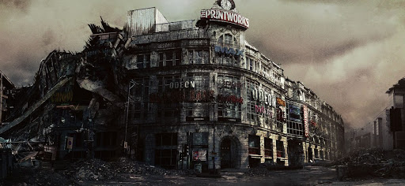

……………………………………………………………………………………………………………………………………………………………………………………………………………...
………………………………………………………………………………………………………
Use these words:
Leaden - dull grey
Deserted - empty
Sinister - giving an evil impression

Writing Workshop

Think about how you are going to persuade Mrs Molyneux to organise your trip idea. Write an Imagine 3 examples: sentence to do this. These sentences need to be perfect before they go into the Sentence Store.
……………………………………………………………………………………………………………………………………………………………………………………………………………...
……………………………………………………………………………………………………………………………………………………………………………………………………………………………………………………………………………………………………………………………………………………………………………………………………………………………...
Ready, Steady, Read
Shakespeare’s Globe: Ultimate Guide
Nestled near the Tate Modern and the Millennium Bridge, Shakespeare’s Globe Theatre may seem a little out of place. It was, after all, designed after the original Globe Theatre which was built in 1599. The modern-day Globe Theatre is an oak-and-thatch replica of the original 1599 Elizabethan playhouse, which once sat about 200 metres from where the Globe stands today, and as a result concertgoers will feel as if they’ve been transported back to Elizabethan times when watching a performance.

Today the theatre serves as an open-air venue dedicated to the work of Shakespeare, and some of the many performances visitors can still watch at the playhouse include A Midsummer Night’s Dream, Macbeth, The Taming of the Shrew, and many, many more.
Visitors can sit on the wooden benches, which can sit up to 340 people, surrounding the stage, or in any of the two tiers of galleried seating. Attendees can even stand directly in front of the stage, just as they did in the original theatre during Elizabethan times.

Questions:
- Which buildings is the Globe Theatre near?
………………………………………………………………………………………………
………………………………………………………………………………………………
- What is the modern-day Globe Theatre made out of?
………………………………………………………………………………………………
- What was the name of the times when the Globe theatre was built?
………………………………………………………………………………………………
- How many people do the wooden benches hold?
………………………………………………………………………………………………
- What is the purpose for this piece of writing? What audience is it written for?
………………………………………………………………………………………………
………………………………………………………………………………………………
- Find a synonym for ‘copy’ in the passage.
………………………………………………………………………………………………
Nestle - to lie comfortably within or against something, e.g. The child nestled in her mother’s arms.

Write a sentence using the word nestle.

Rhetorical Writing - Session 6
Planning Practice: Topic sentences
The topic sentence is the first sentence of a paragraph that introduces the topic. The points in the rest of the paragraph develop and back up the topic sentence.
Example: I believe a trip to Shakespeare’s Globe Theatre, which is a famous historical landmark in central London, would be a wonderful experience for Year 7. We can predict this paragraph will be all about the Globe Theatre.

- Identify the topic sentence below by writing TS next to it.
- Number the other sentences in the most logical order.
- Identify the concluding sentence by writing CS next to it.
- On Christmas Day, families have a traditional meal.
- Christmas is a popular Christian holiday that is celebrated across the UK.
- After dinner, families play games and watch television.
- At this time, friends and families give each other presents.
- Although other celebrations are popular, Christmas is everyone’s favourite time of year!
- There are two bank holidays: Christmas Day and Boxing Day.
Turn the topic sentence into a noun, which, where, who sentence.

Planning Practice: Paragraph Structure
Identify the points that best support Topic Sentence 1 and Topic Sentence 2 by writing 1 or 2 next to them.
TS1 - The Globe Theatre is a brilliant place to visit when you are in London.
TS2 - The Globe Theatre is steeped in history.
- Replica of a original - built 1599
- Shakespeare acted there
- Close to other landmarks - art galleries, museums
- On the famous River Thames
- Shakespeare’s plays were performed there
- You can have a tour - learn about Elizabethan theatre and life
- You can see plays there
- World famous
Now you are going to plan the central paragraphs of your letter on the planning sheet.
Here is an example:
Topic Sentence - I believe a trip to Shakespeare’s Globe Theatre, which is a famous historical landmark in central London, would be a wonderful experience for Year 7.
- Visit capital city
- Learn more about Shakespeare and Elizabethan England
- See a play
- Explore the city and nearby landmarks
Concluding sentence: The more educational the trip is, the more valuable it will be for our futures.

Writing Challenge 2 - As well as the Night at the Museum trip, Mrs Molyneux is thinking of organising another Year 7 trip this year. Write her a letter, informing her of your trip idea and persuading her to choose your plan.
My address:
…………………………….
…………………………….
…………………………….
Recipient’s address:
Hill Cot Rd,
Astley Bridge,
Bolton BL1 8SN

Date:..................................

Dear Mrs Molyneux,
Introduction: ……………………………………………………………………………………………………………………………………………………………………………………………………………………………………………………………………………………………………………………...
Main Paragraph 1
TS:.....................................................................................................................................................................................................................................................................
- …………………………………………………………...
- ……………………………………………………………
- ……………………………………………………………
- …………………………………………………………....
CS:.....................................................................................................................................................................................................................................................................
Main Paragraph 2
TS:.....................................................................................................................................................................................................................................................................
- …………………………………………………………...
- ……………………………………………………………
- ……………………………………………………………
- …………………………………………………………....
CS:.....................................................................................................................................................................................................................................................................
Main Paragraph 3
TS:.....................................................................................................................................................................................................................................................................
- …………………………………………………………...
- ……………………………………………………………
- ……………………………………………………………
- …………………………………………………………....
CS:.....................................................................................................................................................................................................................................................................
Main Paragraph 4
TS:.....................................................................................................................................................................................................................................................................
- …………………………………………………………...
- ……………………………………………………………
- ……………………………………………………………
- …………………………………………………………....
CS:.....................................................................................................................................................................................................................................................................
Conclusion:
……………………………………………………………………………………………………………………………………………………………………………………………………………………………………………………………………………………………………………………...………………………………………………………………………………………………………Yours sincerely,
Name:.............................................

Ready, Steady, Read

Your headteacher is thinking about cancelling the prom. Write a letter convincing her not to make this decision.
1.  Dear Ms Webster,  I have heard that you are thinking of cancelling this year’s school prom and am writing to give my opinion on this decision. As a Year 11 student and Gold Tie Prefect, I have been looking forward to the prom throughout my time at Sharples and hope to convince you that my year group deserves this reward. I know you will make the right decision and I would appreciate you taking my arguments into consideration. | 2.  Ms Webster,  I am shocked to hear that you are thinking of cancelling this year’s school prom! It is unbelievable that you would rob us of this celebration that I have been looking forward to throughout my time at Sharples. Don’t you think my year group deserves this reward? Make sure you take my arguments into consideration.
Questions:
- What is the difference between the two introductions?
………………………………………………………………………………………………
………………………………………………………………………………………………
- Which one do you think best suits the audience and purpose?
………………………………………………………………………………………………
………………………………………………………………………………………………
- Give two examples that show the first introduction has a polite tone.
………………………………………………………………………………………………
………………………………………………………………………………………………
- Give two examples that show the second introduction has an angry tone.
………………………………………………………………………………………………
………………………………………………………………………………………………

Plan one main paragraph of this letter with a TS, CS and 4 supporting points.

Rhetorical Writing - Session 7

Starter Task: Match the sentence to the task.

Task  - A guide to a great family day out in London.  - An advert for Madame Tussauds in London.  - An article titled ‘Will we just let our planet burn?’  - A letter to the headteacher persuading her to make the school more environmentally friendly.  - A guide titled ‘10 Tips for Going Green’ | Sentence  - One improvement you could make is banning single-use plastic in school.  - If you don’t cut out single-use plastic right away, you will be responsible for the death of the planet.  - Fancy some celebrity glamour? You could visit Madame Tussauds and meet your favourite film star.  - Visit Madame Tussauds for the amazing opportunity to meet all your favourite stars.  - First, try using less plastic by getting you morning coffee in a reusable cup.
Choose the adjective that best describes the tone of each sentence.

Writing Workshop: Discuss the models below and then complete your own introduction and conclusion in your plan.

Discuss: What makes the introduction and conclusion below successful?
Introduction:
Dear Ms Webster,
I have heard that you are thinking of cancelling this year’s school prom and am writing to give my opinion on this decision. As a Year 11 student and Gold Tie Prefect, I have been looking forward to the prom throughout my time at Sharples and hope to convince you that my year group deserves this reward. I know you will make the right decision and I would appreciate you taking my arguments into consideration.
Conclusion:
In conclusion, the more we have to look forward to, the more revision we will do for our GCSEs. Imagine a group of young people celebrating, proud of the effort they put in, thankful for the reward they’ve received: this is the prom you could gift us.

Yours sincerely,

Rachel Jones
Sentence Store
……………………………………………………………………………
…………………………………………………………………………....
……………………………………………………………………………………………………………………………………………………………………………………………………………...
……………………………………………………………………………………………………………………………………………………………………………………………………………...
……………………………………………………………………………………………………………………………………………………………………………………………………………...
……………………………………………………………………………………………………………………………………………………………………………………………………………...
……………………………………………………………………………………………………………………………………………………………………………………………………………...
……………………………………………………………………………………………………………………………………………………………………………………………………………...
……………………………………………………………………………………………………………………………………………………………………………………………………………...
……………………………………………………………………………………………………………………………………………………………………………………………………………...
……………………………………………………………………………………………………………………………………………………………………………………………………………...
………………………………………………………………………………………………………………………………………………………………………………………………………………
……………………………………………………………………………………………………………………………………………………………………………………………………………...
……………………………………………………………………………………………………………………………………………………………………………………………………………...
………………………………………………………………………………………………………………………………………………………………………………………………………………
……………………………………………………………………………………………………………………………………………………………………………………………………………...
……………………………………………………………………………………………………………………………………………………………………………………………………………...
……………………………………………………………………………………………………………………………………………………………………………………………………………………………………………………………………………………………………………………………………………………………………………………………………………………………...
……………………………………………………………………………………………………………………………………………………………………………………………………………...
……………………………………………………………………………………………………………………………………………………………………………………………………………………………………………………………………………………………………………………………………………………………………………………………………………………………...
……………………………………………………………………………………………………………………………………………………………………………………………………………...
……………………………………………………………………………………………………………………………………………………………………………………………………………………………………………………………………………………………………………………………………………………………………………………………………………………………...
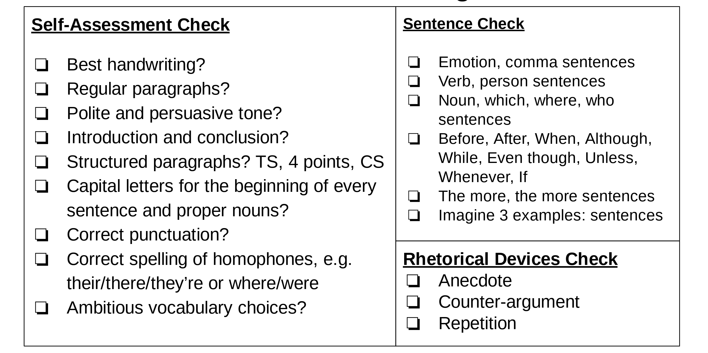
………………………………………………………………………………………………………

Ready, Steady, Read
Preface to Mrs Beeton’s Book of Household Management, published in 1861

I must frankly own, that if I had known, beforehand, that this book would have cost me the labour which it has, I should never have been courageous enough to commence it. What moved me, in the first instance, to attempt a work like this, was the discomfort and suffering which I had seen brought upon men and women by household mismanagement. I have always thought that there is no more fruitful source of family discontent than a housewife's badly-cooked dinners and untidy ways. Men are now so well served out of doors,at their clubs, well-ordered taverns, and dininghouses, that in order to compete with the attractions of these places, a mistress must be thoroughly acquainted with the theory and practice of cookery, as well as be perfectly conversant with all the other arts of making and keeping a comfortable home.

Questions:
- What ‘moved’ (inspired) Mrs Beeton to write the book?
………………………………………………………………………………………………
………………………………………………………………………………………………

- What can bring ‘discontent’ (unhappiness) to a family?
………………………………………………………………………………………………
………………………………………………………………………………………………

- What three places does she list that men can visit outside of their own houses?
………………………………………………………………………………………………
………………………………………………………………………………………………

- What must a mistress be good at?
………………………………………………………………………………………………
………………………………………………………………………………………………

- How can you tell that this was written in the 19th Century and is not modern?
………………………………………………………………………………………………
………………………………………………………………………………………………
Frankly - Honestly. Use the word frank/frankly in a sentence.
Rhetorical Writing - Session 8

Writing Challenge 3 - Write a speech to give on Year 6 New Intake Day explaining the Sharples Bacc and persuading them to get involved.

Type?

Audience?

Purpose?

Starter Task: Add a which, where, who subordinate clause to these sentences.

- Sharples football team finished top of the league.
- Miss Booth ran Science Club.
- The girls attended Art Club every week.
- The gym was recently refurbished.
- The library has a brilliant range of books.
Write your own noun, which, where, who sentences to describe your favourite trips and clubs at school.

Sentence Practice: embedded clause sentences
Example: New York City, the largest city in the United States, is a major tourist attraction.
- Match the noun with the embedded clause.
- Use them to create embedded clause sentences.

- Sharples School  - Ms Webster  - Bolton  - Harry Potter  - George Orwell | - the headteacher of Sharples School  - built in the 1970s  - a town in Greater Manchester  - born in 1903  - a character created by  J.K. Rowling

……………………………………………………………………………………………………...
……………………………………………………………………………………………………………………………………………………………………………………………………………...
………………………………………………………………………………………………………………………………………………………………………………………………………………
……………………………………………………………………………………………………………………………………………………………………………………………………………...
……………………………………………………………………………………………………………………………………………………………………………………………………………..

Write your own embedded clause sentence to describe yourself.

Writing Workshop
Think about how you could describe the Sharples Bacc. Write three embedded clause sentences. These sentences need to be perfect before they go into the Sentence Store in your exercise book.
Self-Assessment Check
- Is my writing punctuated correctly?
- Could I improve the vocabulary?
- Is my tone friendly and persuasive?
- Could I add figurative language?

Ready, Steady, Read
Nigel Slater’s description of going to a sweet shop as a child.

When I had been particularly good - or, as I suspect now, my father had been particularly bad - he would drive me to the sweet shop on Coleway Road. On the wall behind the counter were row upon row of sweetie jars, their lids so round and wide the assistant could barely get her hand around them. There were sweets of vermilion and rose, saffron and lemon, and twists of amber and green. Pear shapes, lozenges and elegant little comfits, wine gums with 'port' and 'brandy' embossed upon them, and black-and-white humbugs as shiny as a Venetian marble floor. Some shone emerald and deepest ruby like precious gems, others pale and delicate in old-lady shades of violet and lavender. Fairy drops and barley sugars, chocolate toffees and midget gems, fruit jellies and sugared almonds, all imprisoned in glass jars.

Vermillion - bright red
Comfit - a type of sweet

Questions:
- Who took Slater to the sweet shop?
………………………………………………………………………………………………
- Look at the underlined sentence. What element of the sweets is the writer describing? Why?
………………………………………………………………………………………………
………………………………………………………………………………………………
- Why does the writer use so many lists in his description?
………………………………………………………………………………………………
………………………………………………………………………………………………
- Find a simile in the passage.
………………………………………………………………………………………………
………………………………………………………………………………………………
- Give three adjectives to describe how Slater feels about the sweet shop.
………………………………………………………………………………………………
………………………………………………………………………………………………

imprisoned - trapped/kept in prison
Use the word imprison/imprisoned in a sentence.

Rhetorical Writing - Session 9

Starter Task: Apostrophes either indicate missing letters (contractions) or show possession.

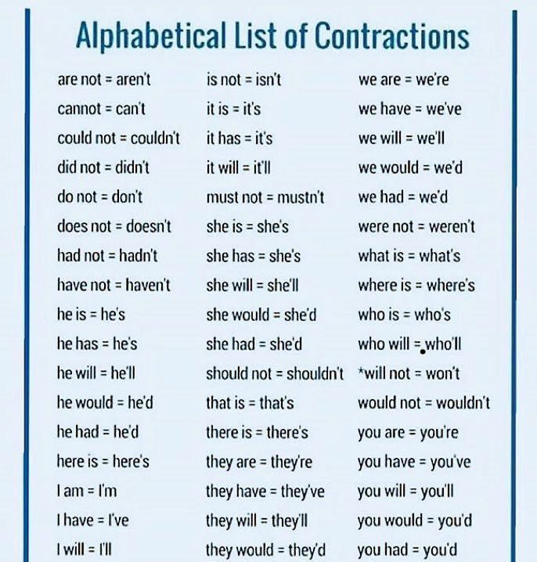

Possession
When the owner is singular:
The pen of the student The student’s pen
The football kit of Chelsea Chelsea’s football kit
The room of Rachel Rachel’s room
The town centre of Bolton Bolton’s town centre
The scarf of Jess Jess’s scarf

When the owners are plural:
The classroom of the students The students’ classroom
The football of the two girls The girls’ football
The habitat of the tigers The tigers’ habitat

Exception
The cat licked its paws. (it’s = it is)

Correct the sentences below:
- The boy’s wanted to go and see theyre friend.
- Rayhans gloves were nowhere to be seen.
- The sea isnt rough today. It’s waves are gentle.
- Boltons shop’s are varied: you can find clothing, homeware and sportswear there.
- “Wheres John?” Sam asked.
- The friends treehouse was where they met to play games.
- Theyd wanted to find Rebeccas exercise book but they couldnt see it anywhere.
Sentence Practice: De:De sentences - Description: Detail
Example: Cheetahs are remarkable animals: they can run up to the speed of 93km per hour.

Complete the detail section of these sentences:

- The Sharples Bacc is brilliant:..............................................................................
……………………………………………………………………………………………...
- Being a subject ambassador is brilliant:................................................................
……………………………………………………………………………………………...
- Sharples School is the best:.................................................................................
……………………………………………………………………………………………...
- English lessons are very useful:...........................................................................
……………………………………………………………………………………………...
- Clubs are amazing:..............................................................................................
……………………………………………………………………………………………..

Write your own De:De sentences from scratch.

Writing Workshop
Think about how you could describe the Sharples Bacc. Write three De:De sentences. These sentences need to be perfect before they go into the Sentence Store.
……………………………………………………………………………………………………...
……………………………………………………………………………………………………………………………………………………………………………………………………………...
………………………………………………………………………………………………………………………………………………………………………………………………………………
……………………………………………………………………………………………………………………………………………………………………………………………………………...
……………………………………………………………………………………………………………………………………………………………………………………………………………..

Self-Assessment Check
- Is my writing punctuated correctly?
- Could I improve the vocabulary?
- Is my tone friendly and persuasive?
- Could I make my detail more specific?
- Could I add figurative language?

Ready, Steady, Read
A Walk in the Woods by Bill Bryson

Imagine, if you will, lying in the dark alone in a little tent, nothing but a few microns of trembling nylon between you and the chill night air, listening to a 400-pound bear moving around your campsite. Imagine its quiet grunts and mysterious snufflings, the clatter of upended cookware and sounds of moist gnawings, the pad of its feet and the heaviness of its breath, the singing brush of its haunch along your tent side. Imagine the hot flood of adrenaline, that unwelcome tingling in the back of your arms, at the sudden rough bump of its snout against the foot of your tent, the alarming wild wobble of your frail shell as it roots through the backpack that you left casually propped by the entrance—with, you suddenly recall, a Snickers in the pouch. Bears adore Snickers, you’ve heard.

Questions:
- Where is the writer?
………………………………………………………………………………………
- How heavy is the bear?
………………………………………………………………………………………
- Look at the underlined sentence. Find all the onomatopoeic (sound) words in the sentence.
………………………………………………………………………………………
………………………………………………………………………………………
………………………………………………………………………………………
- Find a metaphor in the passage.
………………………………………………………………………………………
- Give three adjectives to describe the tone of the passage.
………………………………………………………………………………………………
………………………………………………………………………………………………
………………………………………………………………………………………………

frail - weak/delicate. Use the word frail in a sentence.

Rhetorical Writing - Session 10

Sentence Practice: Last word. First word sentences
Example: Building the new motorway could be disastrous. Disastrous because all of the new motorways could be destroyed.

- The Sharples Bacc is brilliant...............................................................................
……………………………………………………………………………………………...
- Being a subject ambassador is brilliant.................................................................
……………………………………………………………………………………………...
- Sharples School is the best..................................................................................
……………………………………………………………………………………………...
- English lessons are very useful............................................................................
……………………………………………………………………………………………...
- Clubs are amazing...............................................................................................
……………………………………………………………………………………………..

Writing Workshop

Think about how you could describe the Sharples Bacc. Write three Last word. First word sentences These sentences need to be perfect before they go into the Sentence Store.
……………………………………………………………………………………………………...
……………………………………………………………………………………………………………………………………………………………………………………………………………...
………………………………………………………………………………………………………………………………………………………………………………………………………………
……………………………………………………………………………………………………………………………………………………………………………………………………………...
……………………………………………………………………………………………………………………………………………………………………………………………………………..

Writing Challenge 3 - Write a speech to give on Year 6 New Intake Day explaining the Sharples Bacc and persuading them to get involved.

Good morning Year 7,
Introduction: ……………………………………………………………………………………………………………………………………………………………………………………………………………………………………………………………………………………………………………………...……………………………………………………………………………………………………………………………………………………………………………………………………………...………………………………………………………………………………………………………
Main Paragraph 1
TS:.....................................................................................................................................................................................................................................................................
- …………………………………………………………...
- ……………………………………………………………
- ……………………………………………………………
- …………………………………………………………....
CS:.....................................................................................................................................................................................................................................................................
Main Paragraph 2
TS:.....................................................................................................................................................................................................................................................................
- …………………………………………………………...
- ……………………………………………………………
- ……………………………………………………………
- …………………………………………………………....
CS:.....................................................................................................................................................................................................................................................................

Main Paragraph 3
TS:.....................................................................................................................................................................................................................................................................
- …………………………………………………………...
- ……………………………………………………………
- ……………………………………………………………
- …………………………………………………………....
CS:.....................................................................................................................................................................................................................................................................
Main Paragraph 4
TS:.....................................................................................................................................................................................................................................................................
- …………………………………………………………...
- ……………………………………………………………
- ……………………………………………………………
- …………………………………………………………....
CS:.....................................................................................................................................................................................................................................................................
Conclusion:
……………………………………………………………………………………………………………………………………………………………………………………………………………………………………………………………………………………………………………………...……………………………………………………………………………………………………………………………………………………………………………………………………………...………………………………………………………………………………………………………
Thank you for listening.

Sentence Store
……………………………………………………………………………
…………………………………………………………………………....
……………………………………………………………………………………………………………………………………………………………………………………………………………...
……………………………………………………………………………………………………………………………………………………………………………………………………………...
……………………………………………………………………………………………………………………………………………………………………………………………………………...
……………………………………………………………………………………………………………………………………………………………………………………………………………...
……………………………………………………………………………………………………………………………………………………………………………………………………………...
……………………………………………………………………………………………………………………………………………………………………………………………………………...
……………………………………………………………………………………………………………………………………………………………………………………………………………...
……………………………………………………………………………………………………………………………………………………………………………………………………………...
……………………………………………………………………………………………………………………………………………………………………………………………………………...
………………………………………………………………………………………………………………………………………………………………………………………………………………
……………………………………………………………………………………………………………………………………………………………………………………………………………...
……………………………………………………………………………………………………………………………………………………………………………………………………………...
………………………………………………………………………………………………………………………………………………………………………………………………………………
……………………………………………………………………………………………………………………………………………………………………………………………………………...
……………………………………………………………………………………………………………………………………………………………………………………………………………...
……………………………………………………………………………………………………………………………………………………………………………………………………………………………………………………………………………………………………………………………………………………………………………………………………………………………...
……………………………………………………………………………………………………………………………………………………………………………………………………………...
……………………………………………………………………………………………………………………………………………………………………………………………………………………………………………………………………………………………………………………………………………………………………………………………………………………………...
……………………………………………………………………………………………………………………………………………………………………………………………………………...

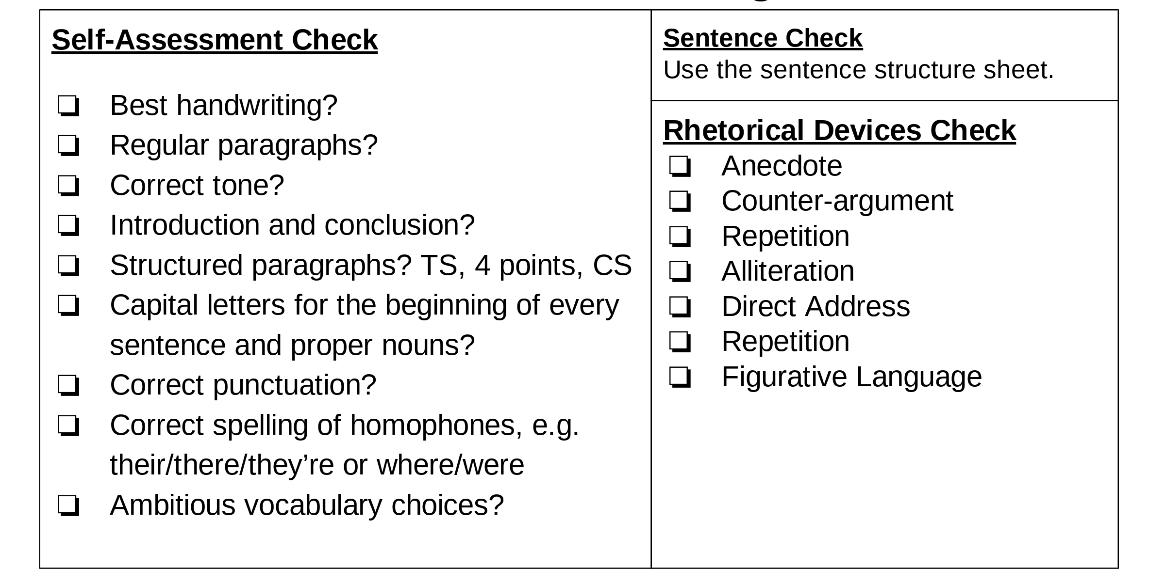

Sentence Types
Verb, person sentence  Holding my breath, I walked through the school gates. | Emotion word, comma sentence  Concerned, the teacher bent down to smile at me. | Noun, which, where, who sentence  The playground, where Year 7 pupils could go at lunchtime, was the biggest in the school.
The more, the more sentences  The more we learn, the more determined we are to make a change. | Imagine 3 examples: sentences  Imagine a time when people were not afraid, when life was much simpler, when everyone helped each other: this is the story of that time. | Embedded clause sentences  New York City, the largest city in the United States, is a major tourist attraction.
Last word. First word sentences  Building the new motorway could be disastrous. Disastrous because many natural habitats could be destroyed. | De:De sentences  Cheetahs are remarkable animals: they can run up to the speed of 93km per hour. | Begin with a conjunction  Before, After, When, Although, While, Even though, Unless, If, Whenever, Since

